Lighting a Croquet Court
As the summer solstice wanes into equinox and winter solstice, croquet buffs around the world yearn for longer playing time. With the average daylight length in warmer winter climates being only 10½ hours, employed individuals would be restricted to playing on weekend or vacation days. The waking hours between 5PM and 9PM need not, and should not, go wasted as valuable playtime. Let’s look into the remedy for nighttime croquet.
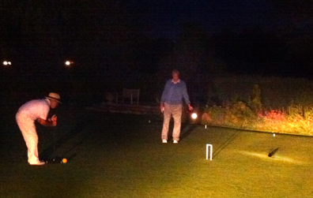

At one time or another we have all used car headlights to light a field for some type of nighttime activity. Obviously there are limits to what automobile headlights can produce. An extreme example perhaps, but the goal here was to extend play into the night, no matter the difficulties in seeing. Young eyes adapt readily to low light situations, whereas older eyes may struggle. Fortunately there are many options for lighting now, but first we must determine what we need or want for light.

Goals

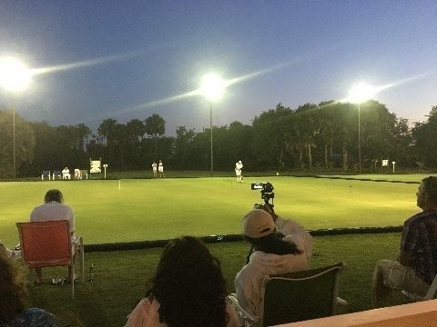
Light intensity
In a search for what would be the right amount of light at court level for croquet, I looked to see what other sports require. It seemed logical that sports that were playing with or trying to hit a moving ball, such as tennis, football or baseball, would need lots of light. Sports not involving a ball such as track and field, swimming and horse racing, would need significantly less. Sports that hit a stationary ball such as golf (driving range) or croquet would also need less. The chart below shows recommendations for various sports with the classes connoting the amount of spectator seating (Class I, 5000 or more; Class IV, none with spectators standing or bring their own chairs).
One of the three, lighted courts at the National Croquet Center, West Palm Beach
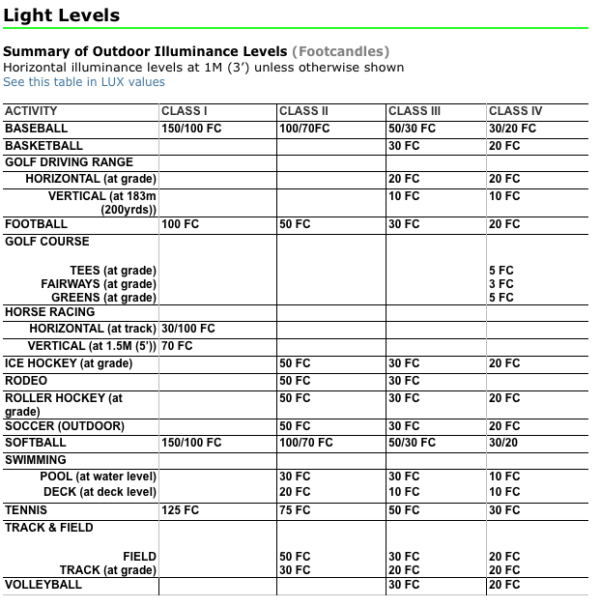
Harold Denton, when researching the NCC lighting project as the project supervisor, compared personally frequented lighted areas, such as indoor dressage barns and other places, and--as concerning the light levels for croquet play--he told me, “this seems about right.” Then he found out what the footcandle value was of all the venues and came to his own conclusion as to what would work for croquet: 22-24 FC at grade, or grass level.

As it turns out, Adam McGee of Associated Eye Care in Kennebunk, Maine came up with essentially the same value (25 FC) when I asked him about an appropriate lighting intensity for croquet, not for the average person, but for a more elderly person with at least beginning vision problems. This brings up a touchy point for some. Harold Denton and I tried to figure what might be the average age of a croquet player and 60ish seemed right to me. Harold thought my estimate was a bit on the youngish side. Nevertheless, the average, older croquet player will need more light. Professional lighting engineers design commonly visited areas for the average population, a 50ish person. The previous chart showed golf tees and greens at 5 FC; a case where hitting and following a white, stationary ball needs little light. Croquet balls, on the other hand are colored and more difficult to tell apart—especially blue and black in lower light situations. Add to that some vision problems and the FC needs rise. Harold and Adam have it about right.

Uniformity
This metric is the difference of the maximum and minimum illumination between any two points on the court surface. In football played for a television broadcast, for instance, the illumination toward any camera from any point on the field can differ no more than 1.4 to 1, from a horizontal or vertical direction and anything in between. Strict rules like these make it much easier for an audience to view the game, whether from a television or in person. Croquet does not require this much uniformity, but it is a good goal for which to strive—particularly for folks with vision issues. In croquet, besides seeing what you are hitting at the level of your feet-- without too much shadowing, you must be consistently able to see a distant target such as a ball, hoop or boundary. On a croquet greensward it actuality might be easier to achieve high caliber uniformity, because croquet operates on a single plane; two dimensions only.

Color Shift
Different kinds of light sources tend to shift the color of objects illuminated. For most, this is not an issue as our eyes adapt readily. It may be a consideration if the surface footcandle value is low and there are underlying vision pathologies.

Light Pollution
Finding the right level of light for your court that falls within town code and that will not bother your neighbor makes for good practice. It matters in what town you reside, who and where your neighbors are and how much light you really need.

Putting It All Together
Once the light level required at grade is decided, the process of building can begin. If you need help in planning, many companies specializing in sports lighting can help such as Light Poles Plus, Musco Lighting, Pro Sports Lighting, Lithonia Lighting…and the list goes on. Every one of these companies provide engineering for the placement and height of poles, the type of light fixtures you might want (along with sales) and their placement, data on the initial cost and cost of operation, and drawings of the electrical wiring. Some companies provide planning, sales and installation contracting; while others provide planning and sales of materials, but no installation.

Engineering
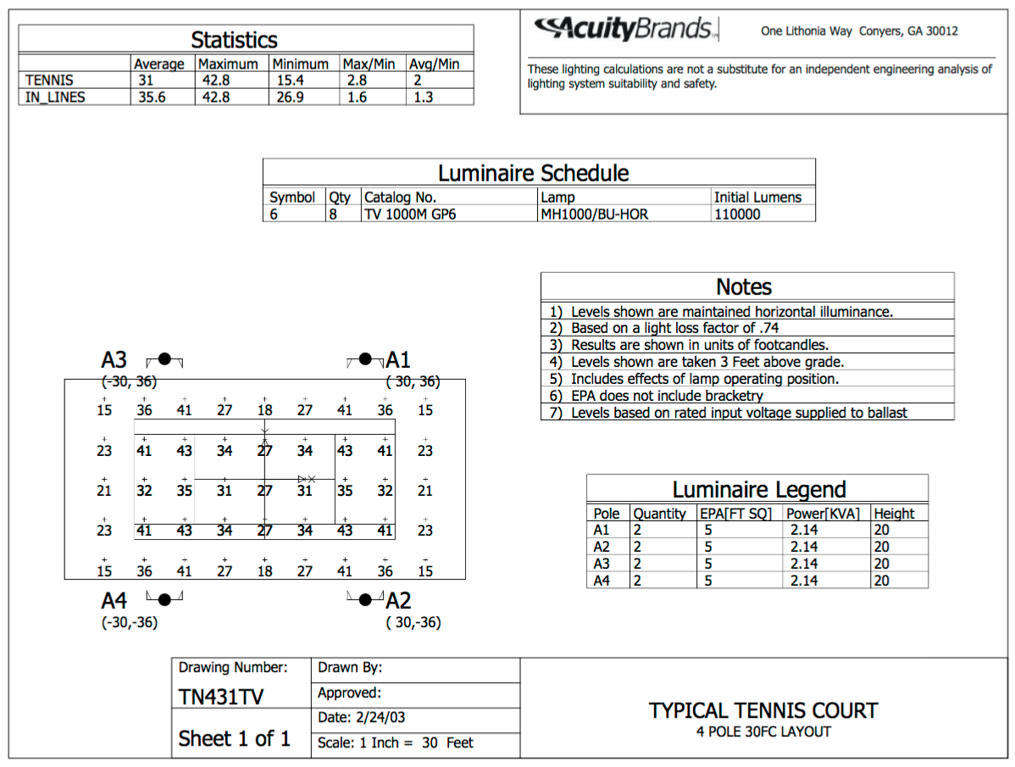
Below is the type of report (this one for tennis) from a lighting company that was generated by a computer. It takes into account the height and placement of the pole, and the number and type of light fixtures and their aim toward the court. You can see from the distribution of light on the court diagram that in the critical areas of play (within the court boundaries), the uniformity of light—in this case at 3 feet off the ground--remains consistent. Lighting at the net and on the sidelines remains less intense, but certainly still practical. Plan to have the company of your choice provide this engineering for your croquet court. In the appendix find a sample plan.

Light Fixtures
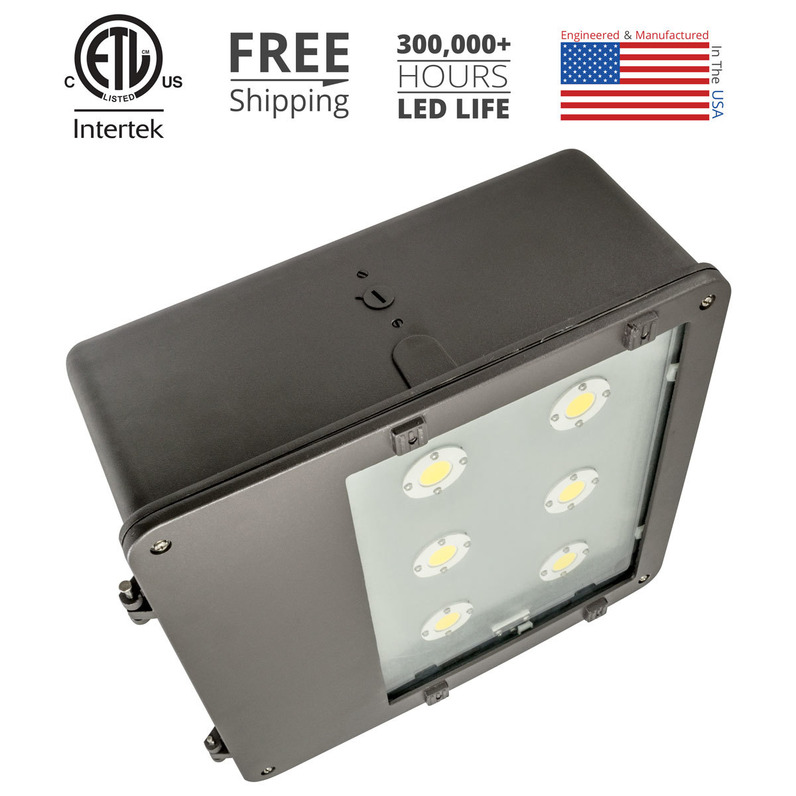
In today’s world of lights the LED has taken center stage. The price has come down significantly. You will still pay more for the initial cost, but maintenance and energy costs plummet in the long term, so you will save money. HID (high-intensity discharge) lamps such as metal-halide, mercury-vapor, sodium-vapor and xenon short-arc lamps will give you a lower start up cost, but require more maintenance and operating costs. Aaron, at Light Poles Plus, estimated that 8 LED lamps, suitable for lighting a full sized croquet court, would save between $5000 to $6000 over 10 years. This calculation seems logical when one considers that a 250 watt LED lamp creates the same amount of lumens as a 1000 watt metal-halide lamp, which will, in a matter of a few years, lose 30% of its output.

In terms of correlated color temperature (CCT) which is measured in kelvins (K), an ideal CCT would be $≥$ 5000K which light is emitted from a daylight LED. This would give the best representation of color perception, particularly when discerning black from blue.
240w LED, 16" Shoebox Light Fixture, 31849 Nominal Lumens, Heritage Series, USA Made (from a ad at Light Poles Plus)

There’s a long list of available lamps from a myriad of manufacturers. When you have found your supplier, go with their recommendations and ask about a warranty. Likely you’ll get a better one with an LED lamp.

Poles
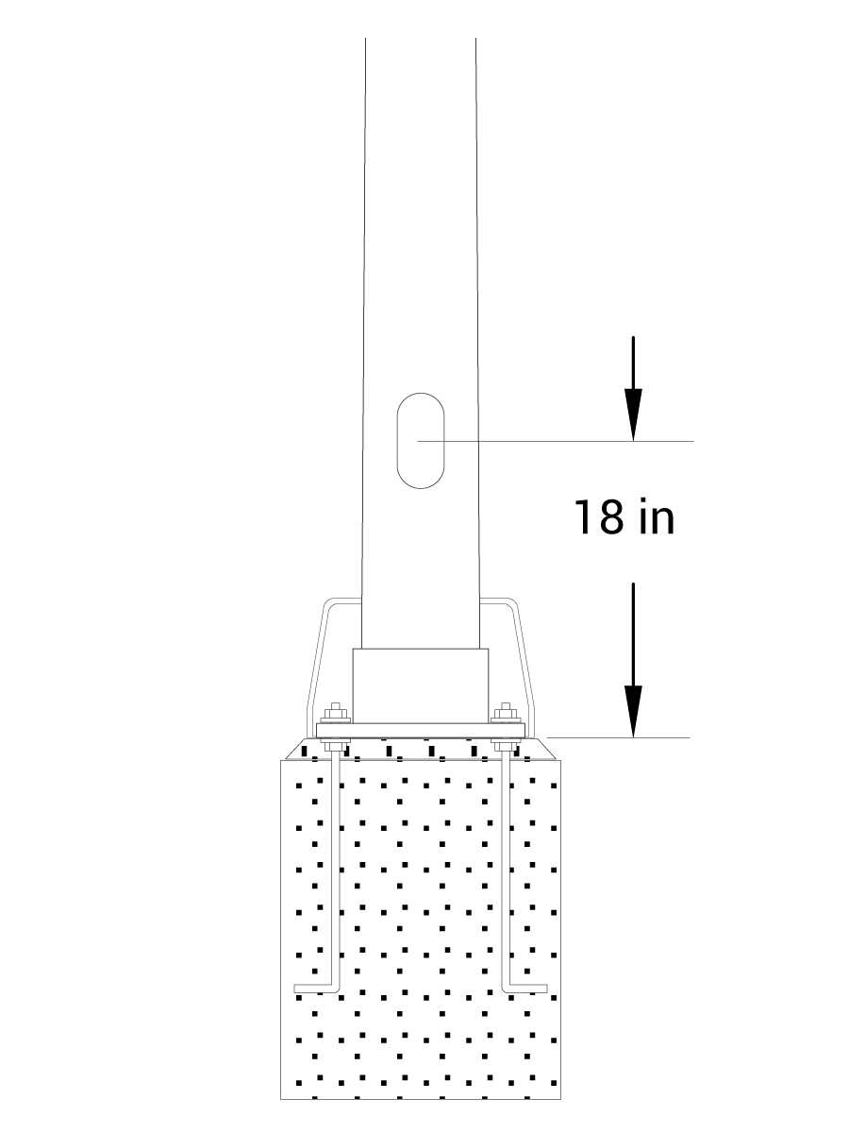
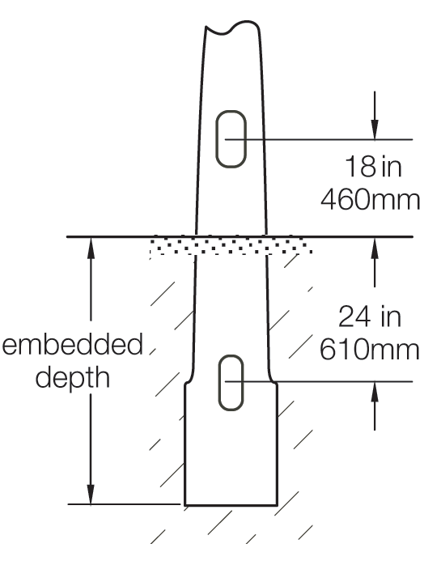
For the purposes of supporting fixtures for croquet lighting, the poles available are made of steel, aluminum or fiberglass; they are straight or tapered and anchored or buried. Every town has a building code ordinance that may address the installation of poles, especially if they have any height and have substantial lights attached. Check with your own town code enforcement officer. Sports lighting companies oftentimes need to address maximum possible winds. For instance, at NCC the pole design needed to survive wind speeds of 170 mph. In Ellsworth and Kennebunkport, Maine, 100 mph is the design speed.
20’ above grade pole
direct burial
20’ above grade pole anchored (in concrete)

The simplest pole setup is the direct burial, which can be handled with manual labor. Trenches for wires and holes for poles can be dug by hand. The NCC used direct burial poles and set the poles and wires with the very competent grounds keeping crew. Driving a cement truck anywhere near a greensward is not recommended.

Electrical

A Little Algebra
For a standard croquet court that has 8 lamps on 4 poles, if the lamps are LED and 250 watts apiece, and the voltage is 220, then the Amperage needed is roughly 9.0;
$$I (\text{Impedance or Amps.})=P\text{(Watts)}÷V(\text{Volts})$$

A more accurate representative equation allows for the power factor of the light in use for AC single phase. For instance a Heritage Series 240 W, 16” Shoebox light fixture has a power factor of $>0.9$, so for 220 volts calculate the following:
$$I\left(\text{Impedance or Amps.}\right)=P\text{(Watts)}÷PF\left(Power Factor\right) × V(\text{Volts})$$

$$I=1920÷(0.9×220)=9.6969(Amps)$$
or at 115 volts

$$I=1920÷(0.9×115)=18.5507(Amps)$$

For an LED setup at 220 volts, the power requirements are rather low and the wiring requirements simple using 14 AWG copper wire, unless there are long runs which would require heavier wire. If you choose to use an HID lamp, the amperage should be multiplied by a factor of four, and the wire should increase to 8 AWG copper (with a significant increase in cost).

Wire and Accessories
All poles available for croquet lighting are fitted with underground or bottom openings to feed electrical cable, through the center of the pole, to the top; or with above ground openings for access from conduit usually through a concrete footing. Poles will also come with an opening at the 18inch, above ground mark for adding junction boxes or simply to help feed cable through to the top. Most folks choose to supply power underground. Cable can be buried directly (UF cable—specially designed for underground) or standard Romex cable can be fed through conduit, the most common and cheapest being PVC (but it should be buried at 18 inches). All connections below ground should be waterproofed. Sometimes it is best to choose more flexible cable that has stranded copper to allow for easier feeding through and around corners.

The main switch for the system should originate from the clubhouse or home. If that is not possible then there should be a locked switch box mounted on one of the light poles or on a separate, short pole. All lamps are wired in parallel and should be mounted on their brackets, aimed and connected to power before the poles are set in place.

Hiring Installers
Some lighting companies can provide front to back, turnkey installations. You will pay for it, probably in spades, but there is no muss, no fuss. One alternative lies in hiring your own local contractors whose services can be bid out. Lastly, one could do the work oneself saving a great deal of money. The costs should be weighed against one another from all options, including combining self-work and contracted work in a mix and match scenario. The contractors you might use are the following:
- Electrician, especially one specializing in underground installations.
- Pole setters such as Power Companies, excavation contractors or a general contractor.
- Advice of a Code Enforcement Officer of your town or municipality.

Town Ordinances
Most towns have an “Outdoor Light Ordinance.” Without getting into the long list of definitions, which all ordinances have, the essence of the Ordinance in my town for instance, is Article 2.2, Control Of Glare-Luminaire Design Factors summarized here.

A. Any luminaire with a lamp or lamps rated at a total of more than 1800 lumens and all flood or spot luminaires with a lamp or lamps rated at more than 900 lumens shall not emit any direct light above a horizontal plane through the lowest direct light-emitting part of the luminaire.

B. Any luminaire with a lamp or lamps rated at a total of more than 1800 lumens and all flood or spot luminaires with a lamp or lamps rated at a total of more than 900 lumens shall be mounted at a height equal to or less than the value 3 + (D/3) where D is the distance in feet to the nearest property boundary.

The maximum height of the luminaire may not exceed 25 feet.

The key phrases in this ordinance are “horizontal plane” and “direct light.” The formula for “luminaire height” does not apply in our case because the height of the pole is limited to 25’. Your ordinance should be shared with the designers of your system, so that local codes are met and your neighbors cannot legitimately complain, except perhaps at a hearing.

Installing Lights
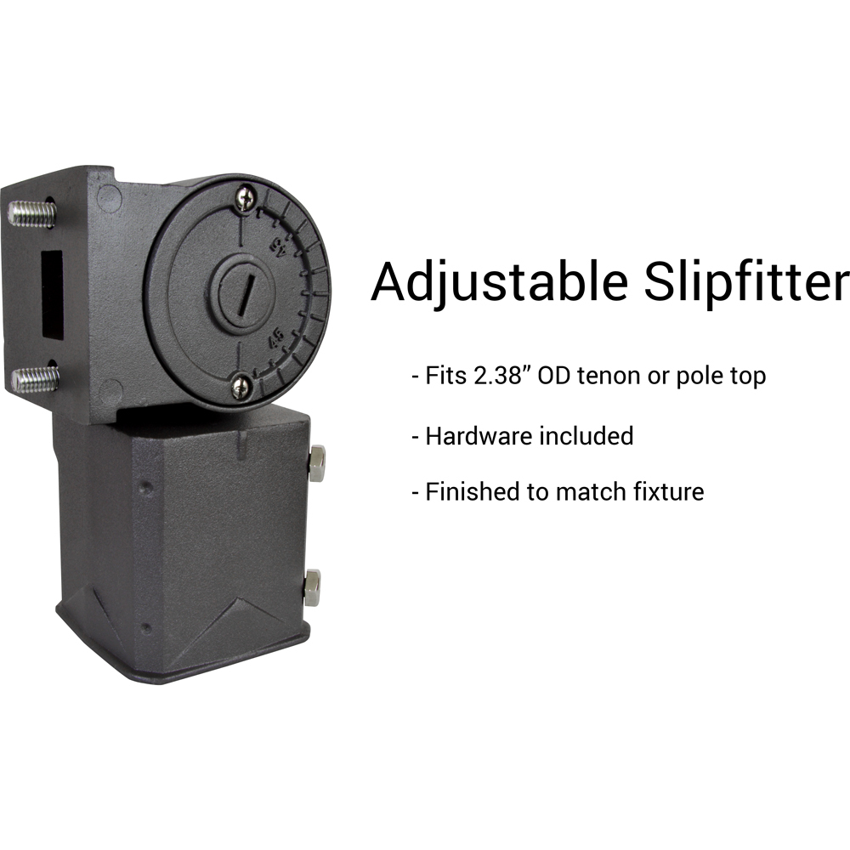
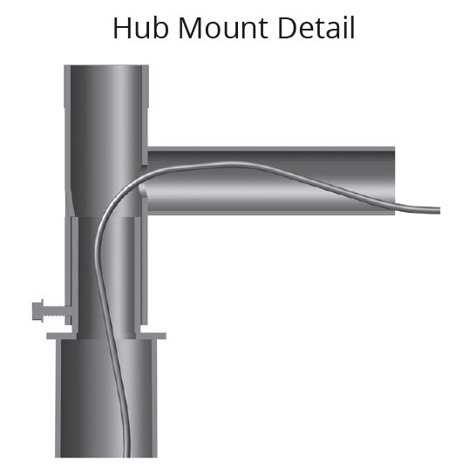
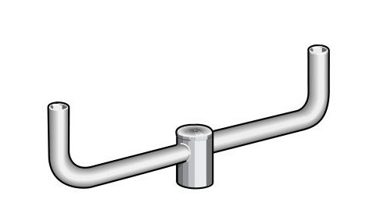
Once one chooses the light designed for the court, it should be mounted and wired before the pole is set. Most engineered plans will have two or more lights on a pole and, therefore, a bracket must be attached. The bracket to the right is a bullhorn design of aluminum; this one supplied by Light Poles Plus. A bracket will be specified to accommodate the wind loads for your area of the world. Wires are fed through the pole into the hollow aluminum bracket and then connected to the light fixture (as shown on the left).
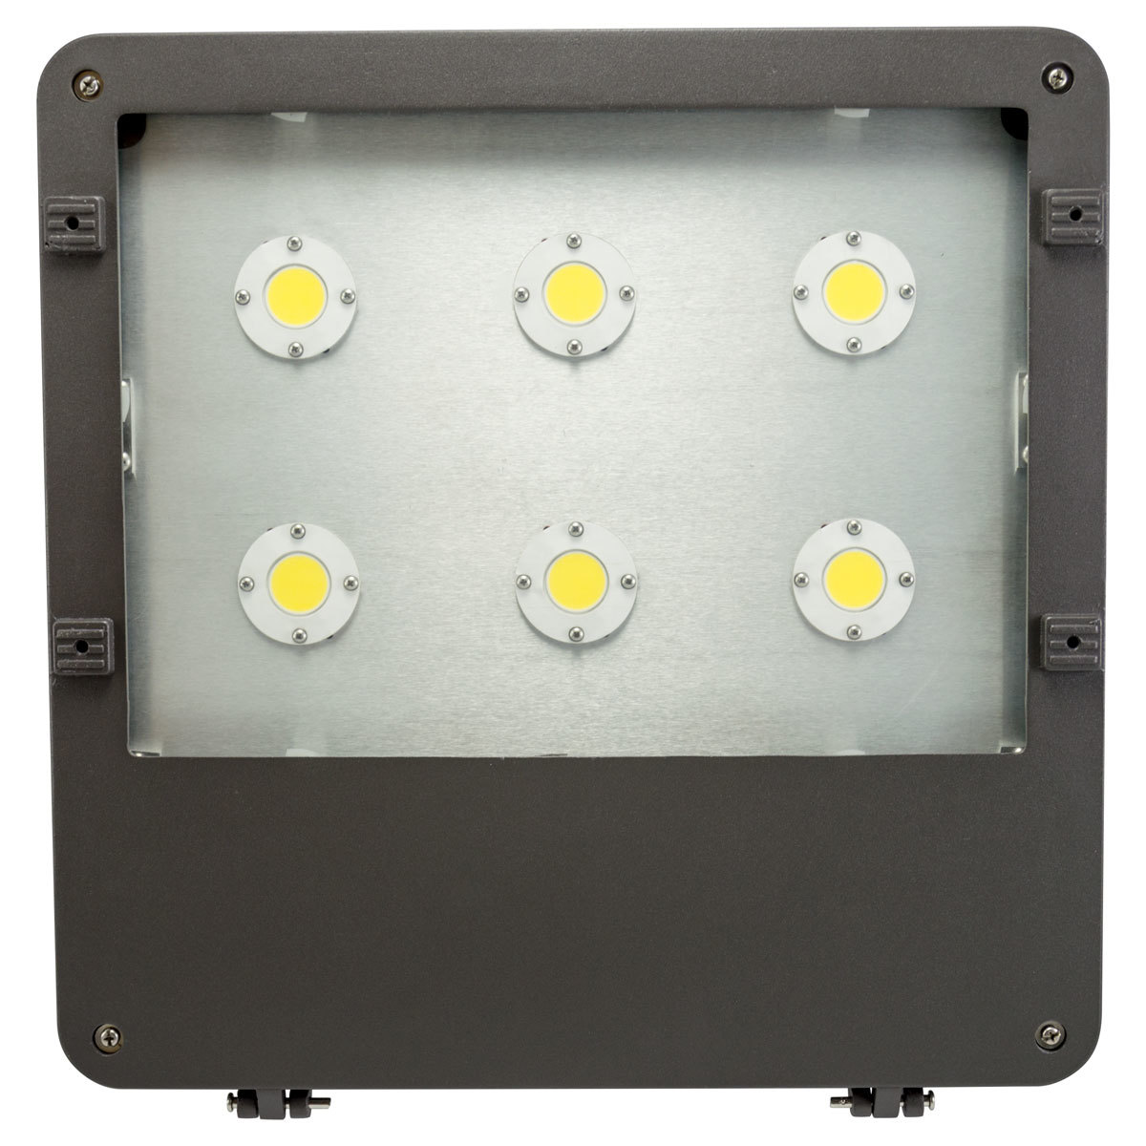
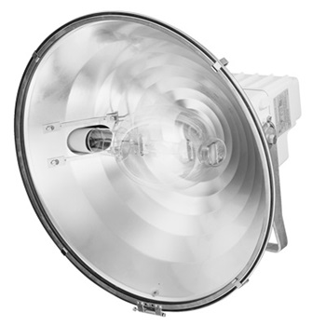
A light such as the Shoebox LED Light Fixture or Architectural Tru-Sport HID Fixture (metal halide) are attached to the bracket tenon using an adjustable slipfitter as shown to the right, or some other similar device. This gives the installer an exacting angle reference for positioning at the engineered specification.

Setting Poles
The trend nowadays leads to direct burial aluminum or fiberglass composite poles. They are lightweight (a 20’ above ground pole has 4 feet beneath the ground or 24’ overall) and easy for several strong people to maneuver. The holes can be excavated with a post-hole digger or a tractor with an auger. The wires can be laid and buried either using UF cable or Romex with conduit. Conduit needs to be connected properly to the pole. The turf can be laid aside and a trench dug by hand or a trench maker can be rented to dig for you. The poles can be prewired and the lamps attached to brackets and connected to power before they are lifted into position. The lamp’s position and aiming angles will be specified by the lighting company engineering, with a deviation allowance built in for inconsistencies in pole settings. The whole assembly could weigh only 150 pounds (according to Light Poles Plus), manageable with several strong people. Once in the pole is set into the hole, the pole is plumbed and rotated into position and the hole is back filled with the excavated dirt, if deemed suitable, and tamped down.

If one desires attached poles, a significant amount of extra work will be required to pour concrete into hole or form, and carefully place retention bolts before the cement sets. Also a conduit allowing the passage of wires through the cement to the center of the pole must be placed. If this project is post-court construction, then getting cement to the site could be problematic and would likely necessitate wheelbarrows or a portable cement mixer. After the foundations are produced, pole placement becomes very tricky and will most likely require a crane or a gin pole for support while it is placed onto the retaining bolts.

A Sample Design
This is an actual quote from a superb company, Light Poles Plus that was gladly willing to help even the small project that is a single croquet court. Bigger companies might brush you off.

Footcandle Array on a Standard Croquet Court; Engineered to 15 FC Average

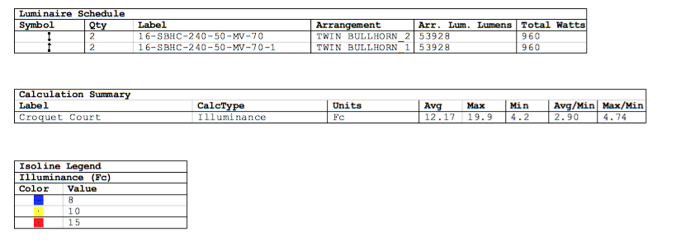
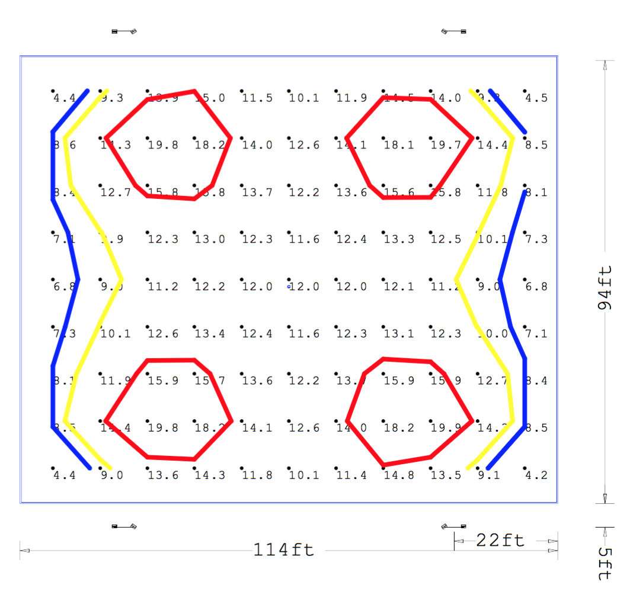
Note how blue’s values are low and black would be even lower. You may want to inquire about the ability to tell black from blue at a distance.

Illuminance Graphics

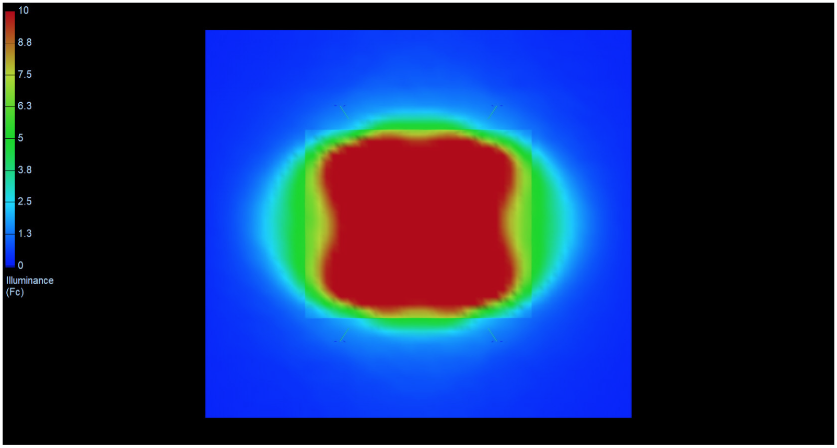

The Quote

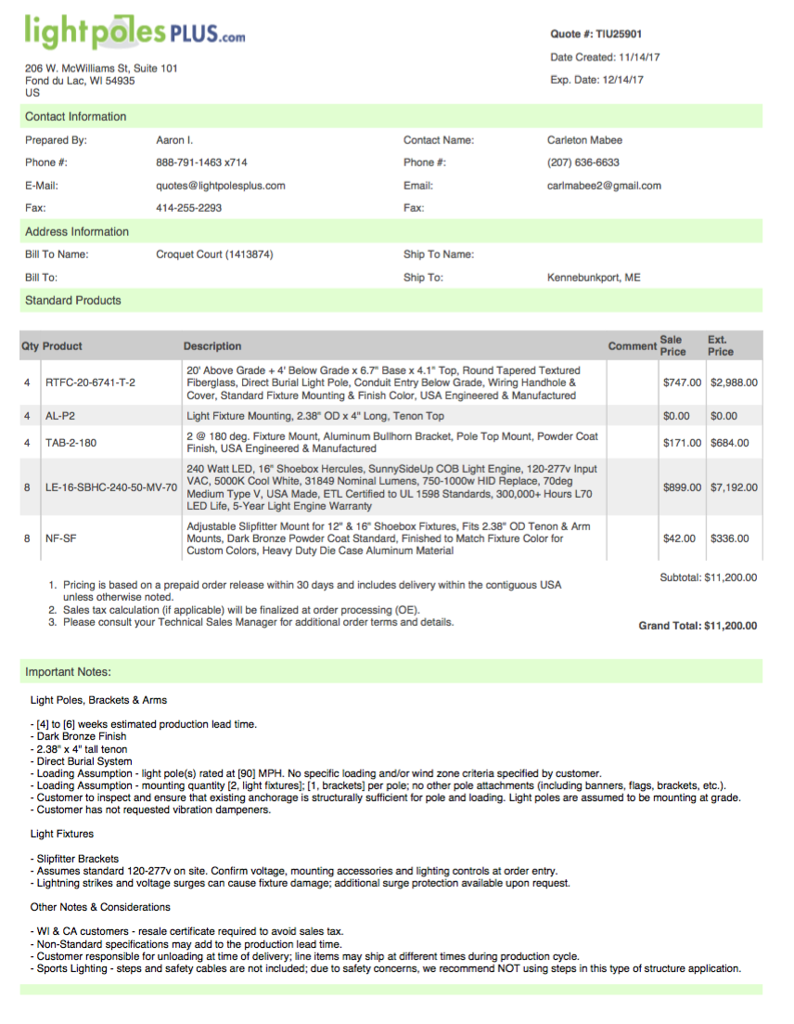

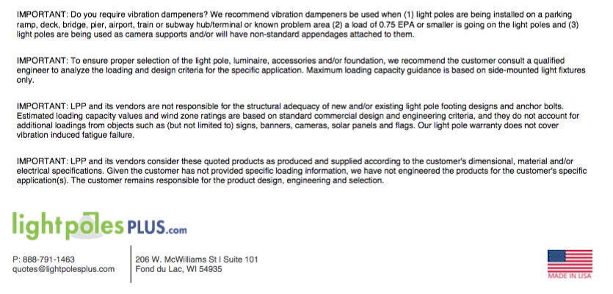

Lamp Details

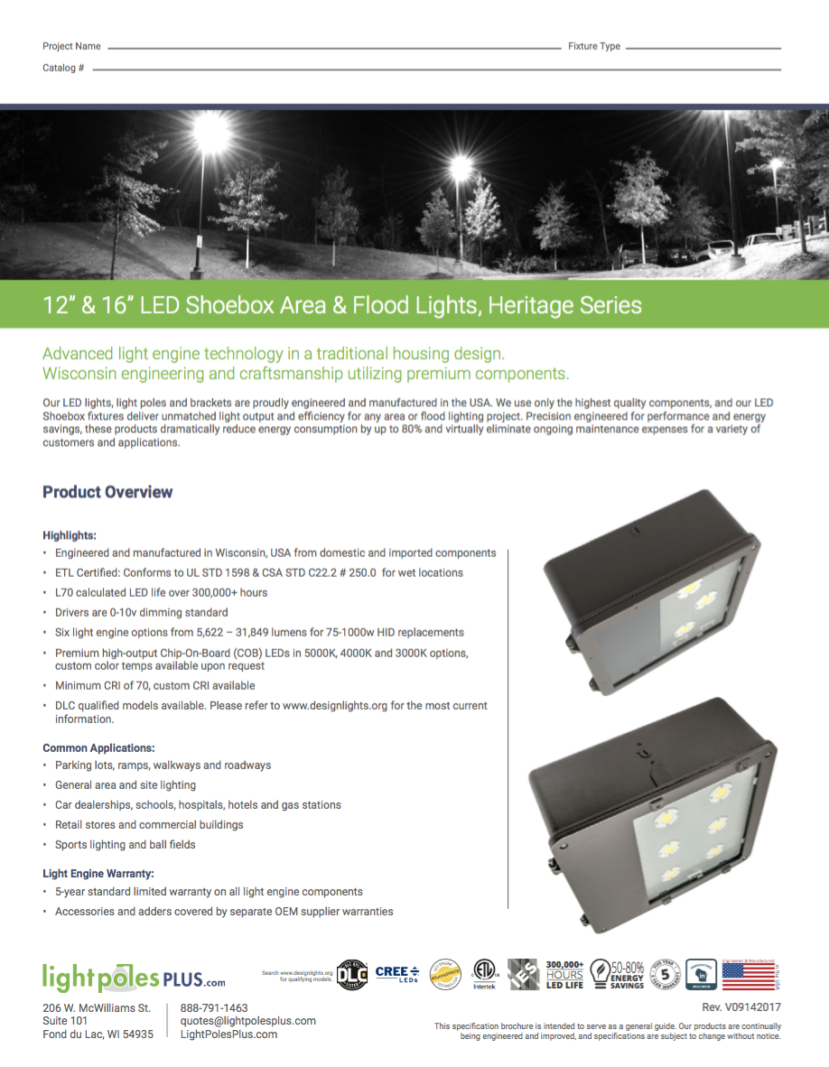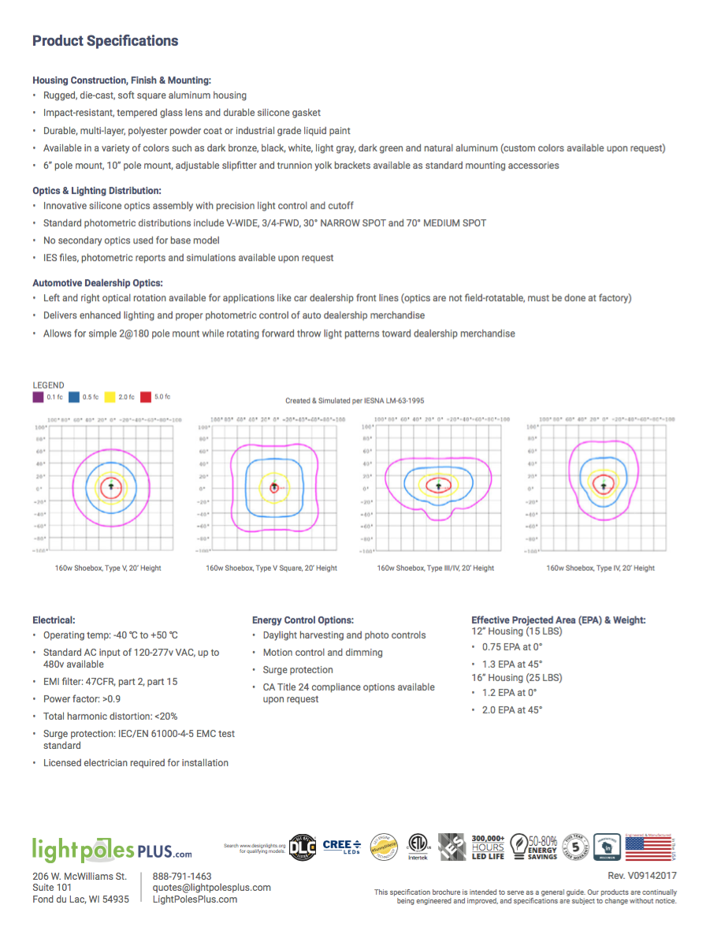

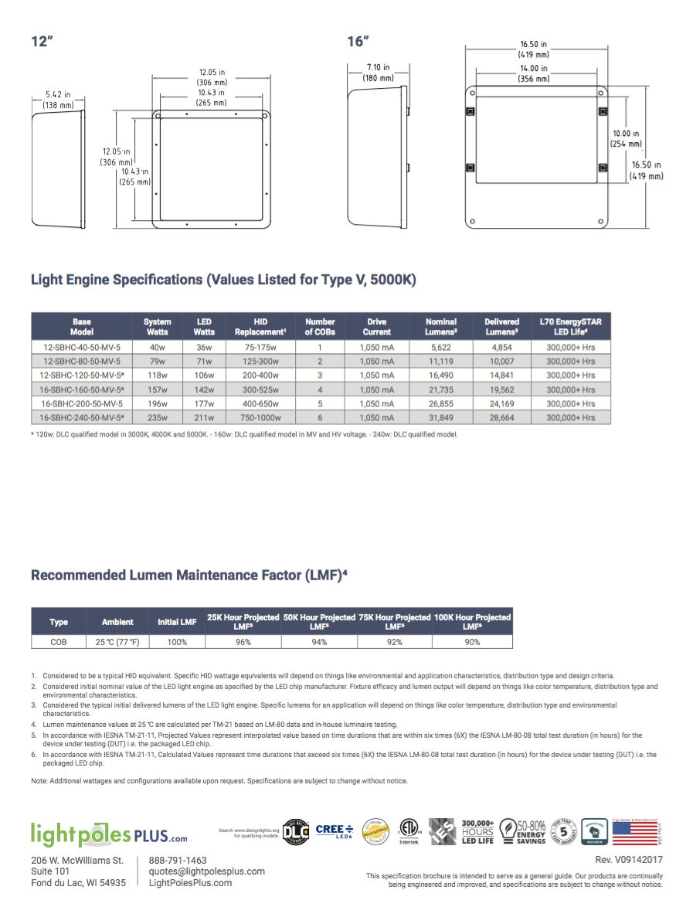
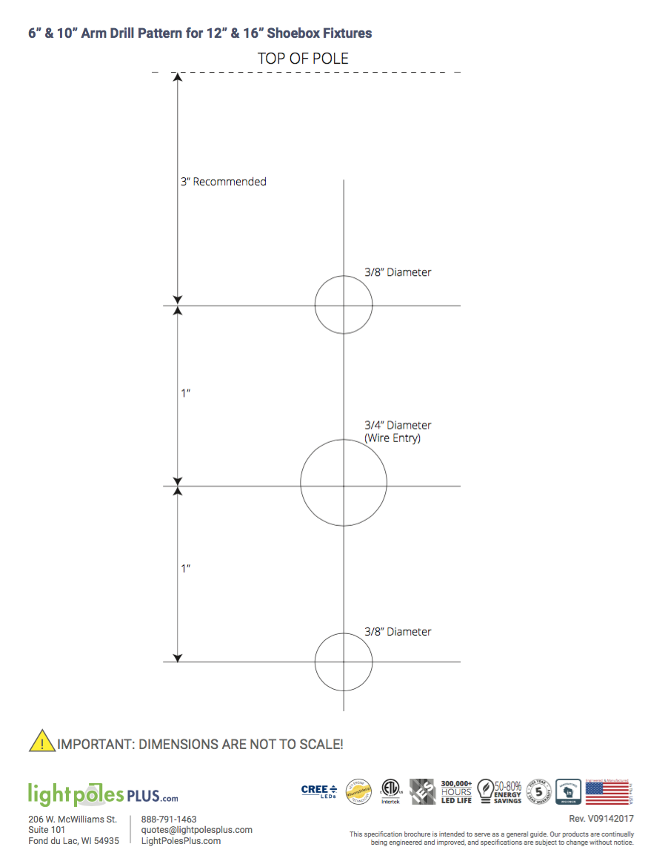
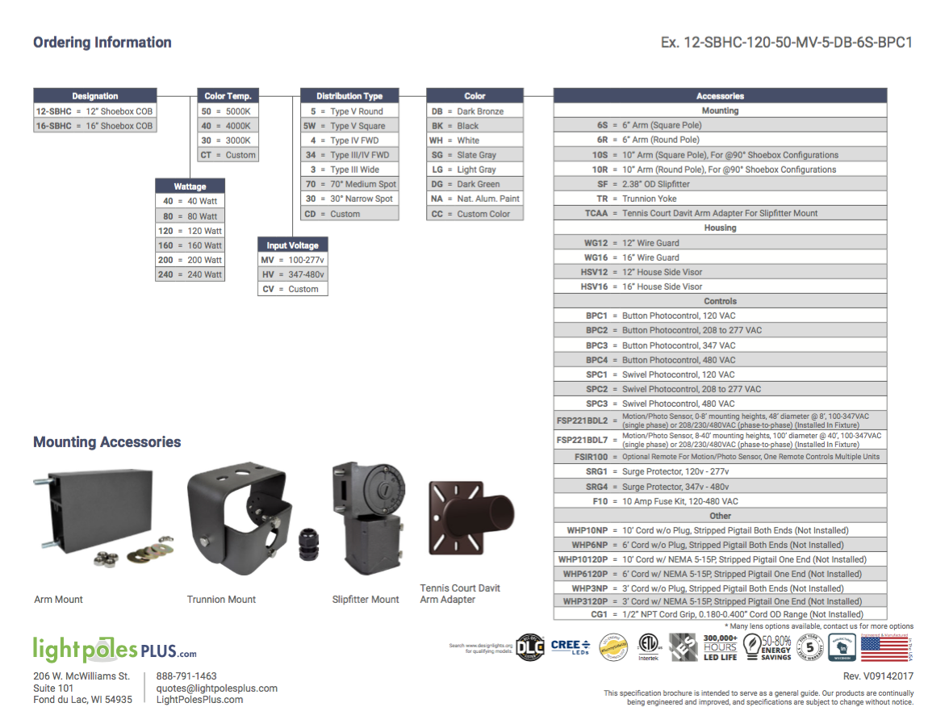
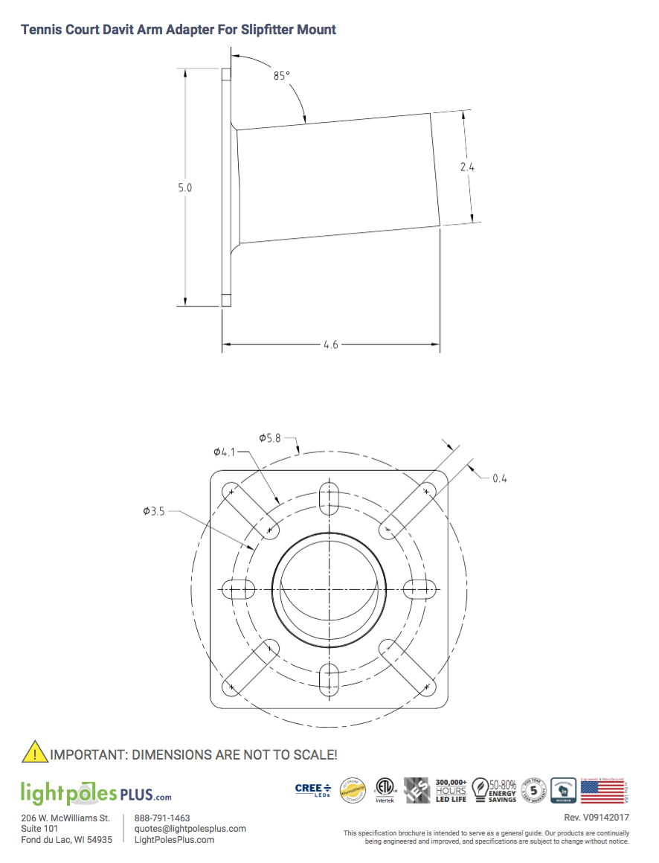

Appendix

A Little Physics

Terminology
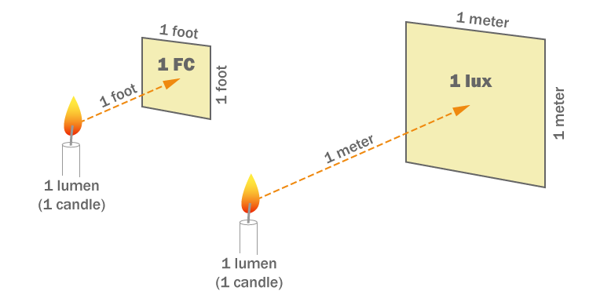
Few of us probably remember High School or College physics, but a few basics will help in understanding the science of lighting. As shown in the diagram one candle, or lumen (a single point of light radiating in all directions), will cast an illuminance (or quantity of light) of one footcandle on a square foot of surface at a distance of one foot. For the metric world it’s one lux on a square meter of surface at a distance of one meter. The footcandle and lux terms become critical when discussing what acceptable light can or must be for all lighted situations. These terms are used consistently in the lighting industry. Converting footcandles to lux is done simply by understanding the relationship between both terms: 1 FC = 10.76 Lux or I Lux = 0.093 FC.

The Inverse-square Law
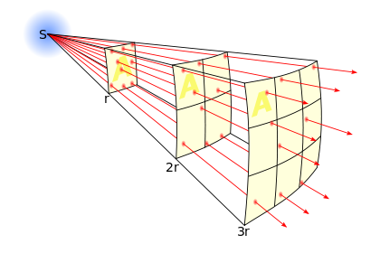
It goes without saying that the closer you are to a light source, the brighter it becomes. With the exception of an extremely narrow, or parallel, beam of light such as a laser beam or a convergent beam (remember starting fires with a magnifying glass?), a light source will lose its power with distance. The inverse square law, based upon a point source of light radiating into three-dimensional space, will decrease in power by $\frac{1}{d^{2}}$ where d = distance. The inverse-square principle is represented in this graphic (where r [or d] = measured points –or radius-- of the sphere).

Beamed Light
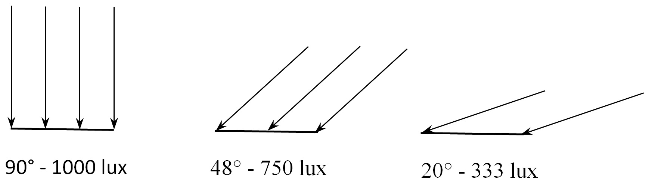
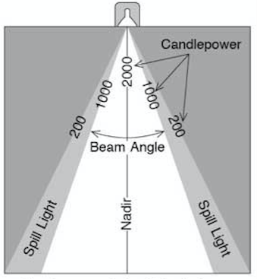
The inverse-square law changes when the light source is beamed in various degrees with reflectors or lenses. What is important here is that the amount of “candlepower” at the source can be of less intensity to accomplish the job. In the graphic shown, the beam angle is determined at the point in the lateral border of the beam where it drops to 50% of its nadir (or directly downward) intensity. So in this case where the nadir intensity is 2000 units and the lateral border reaches 1000 units, the beam angle is determined. In this case the nadir is perpendicular to the surface, but in lighting a sports field the reality is that the angle of incidence will be significantly less than 90˚ as shown at the right.

Duration of Daylight Year Round in West Palm Beach

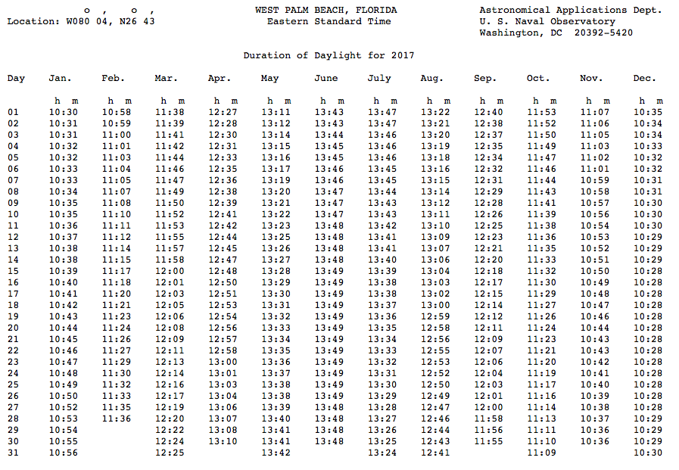

This chart can be reproduced for any place in the world at the following Website:
http://aa.usno.navy.mil/data/docs/Dur_OneYear.php

A Few Light Pole Suppliers

- Light Poles Plus, Fond du Lac, WI https://lightpolesplus.com
- Alliance Composites, Inc., McGaheysville, VA http://www.alliancecompositesinc.com/home/
- Shakespeare a Valmont Brand, Newberry, SC, http://www.skp-cs.com/home
- Bridgewell Resources, Tigard, OR, http://www.bridgewellresources.com/products

A Few LED and HID Lamp Suppliers

- Musco Lighting, Oskaloosa, IA, http://www.musco.com
- Light Poles Plus, Fond du Lac, WI, https://lightpolesplus.com
- Lithonia Lighting, Conyers, GA, http://www.lithonia.com/micro_webs/sportslighting/default.asp
- Acuity Brands (Lithonia Lighting), Atlanta, GA, http://www.acuitybrands.com/products/lighting/outdoor/sports-lighting

Typical Footcandle (FC) and LUX Ratings Outdoors and in Familiar Places

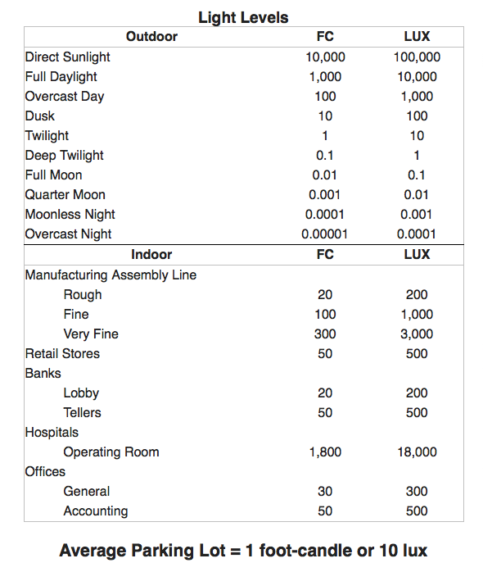

Direct Burial Light Pole Installation

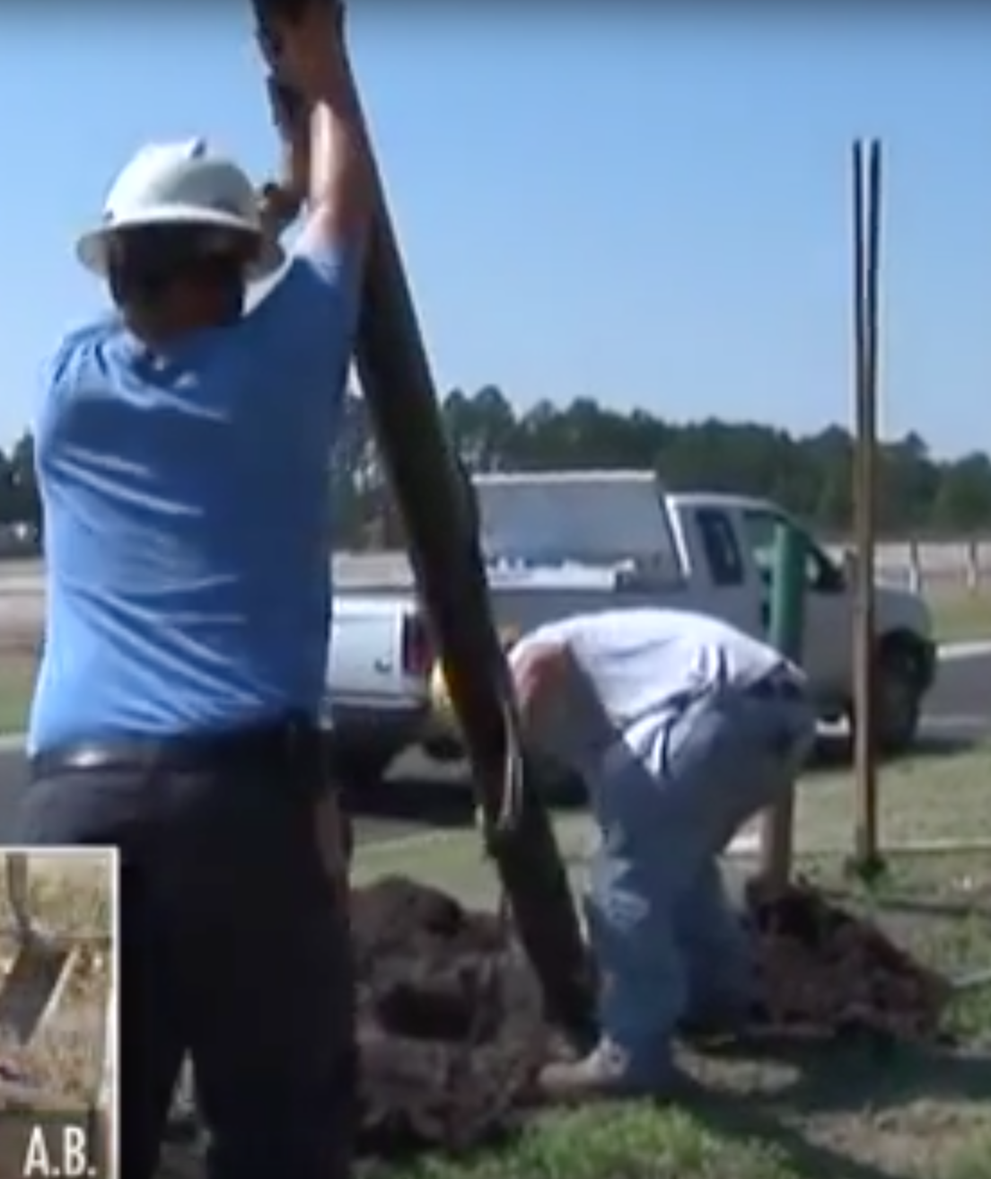
This photo shows a pair of men easily preparing and installing a fiberglass composite pole into a hole dug by the post-hole digger in the background.
This photo is from the video of this project: https://www.youtube.com/watch?v=7grcIJ_5vOU
In order to install Direct Burial Light Poles the correct backfill material for differing soil conditions should be used. The following guidelines are suggested:
Solid Rock Conditions: Crushed rock of 3/4 inch or less or cemented sand should be utilized for backfill.
Poor Soil Conditions: Consisting of loose rock, gravel, highly organic solids, or any other type of soil or conditions that inhibits the creation of a stable structural base. Local experts knowledgeable in existing soil conditions in the local area should be consulted to determine proper soil compaction.
Average Soil Conditions: Consisting of clay, silt, moderately organic soil, or areas with standing water during rainy season. Additional crushed rock to 3/4 inch or less should be added to the excavated material for backfill.
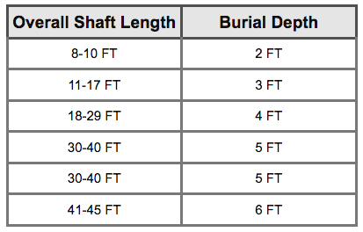
Make The Hole: Generally holes should be round with smooth vertical sides consisting of undisturbed soil for best compaction and stability of poles. Diameter of holes should be about twice the diameter of the pole at its base. Holes should be hand dug or augured. For general burial depth consult the chart below:

Wire the Pole: Complete wiring utilizing approved methods.
Install the Pole: In many cases composite poles can be manually lifted into place and inserted into the hole.
Plumb the Pole: Use a plumb bob to level and align the pole.
Backfill the Hole: Fill and tamp every 6 to 8 inches of backfill. Frequent tamping is important for installation.

An Example of a Manufacturer’s Direct Burial Products
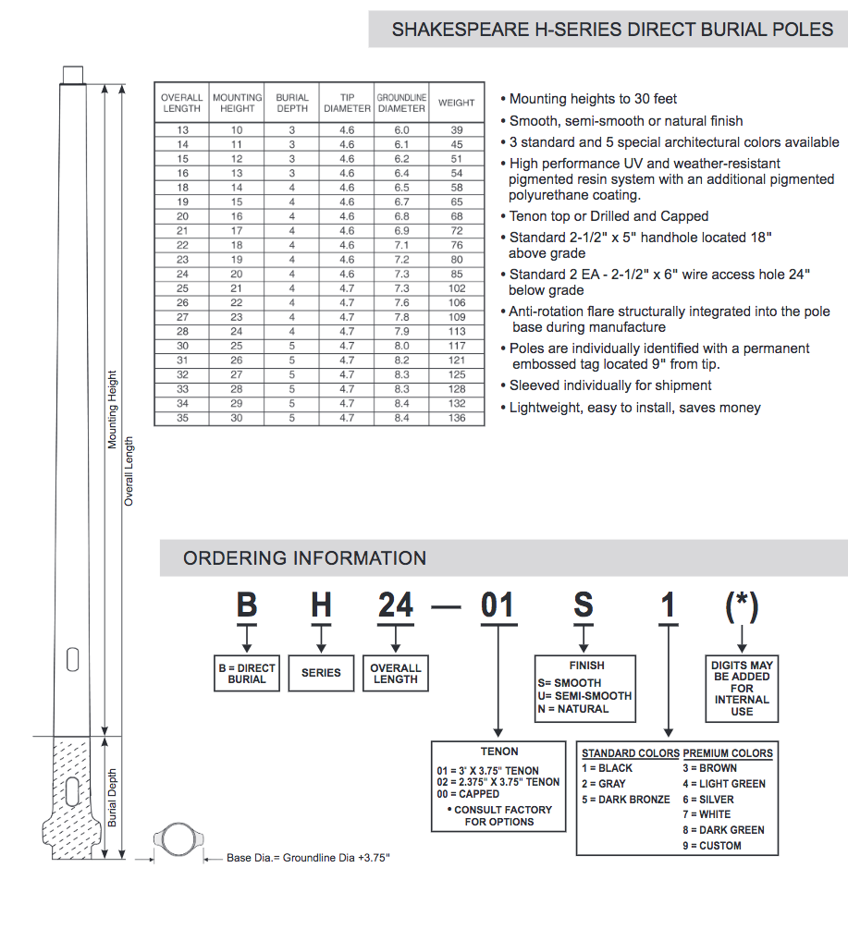

Courts with Lighting

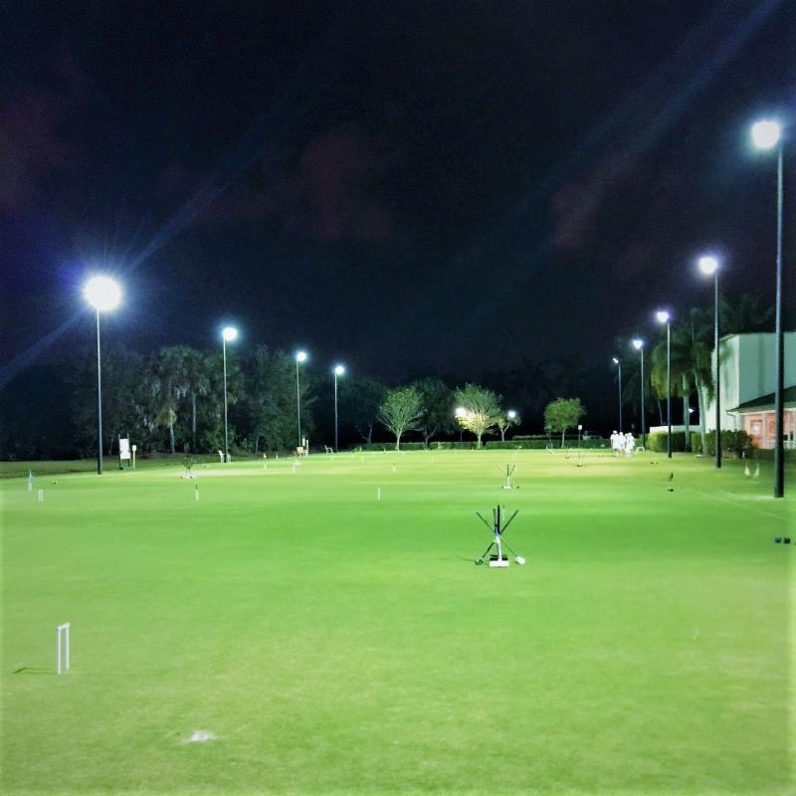
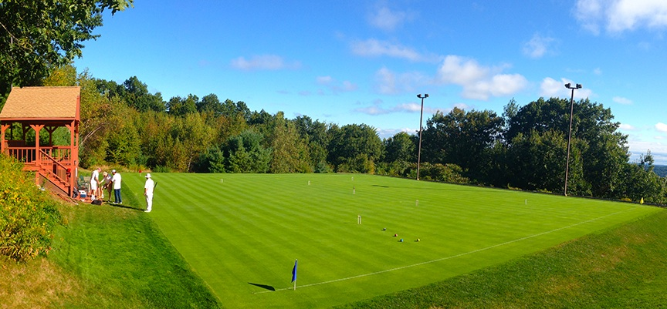
Three lighted courts at the National Croquet Center, West Palm Beach,
with four poles and lamps per court.
Jay DiGeronimo’s court in Leominster, MA
Two poles and four lamps

See appendix for Daylight Duration Charts
Lithonia Lighting Sports Lighting Design Guide, Light Levels; November 7, 2017, http://www.lithonia.com/micro_webs/sportslighting/lightlevels/default.asp
Contributing vision factors requiring more light: Neurodegeneration of the retina and suprachiasmatic nucleus; decreasing pupil size; thickened lenses and cataracts.
Ian Ashdown, “Sports Lighting Regulations,” All Things Lighting; Relevance in Illumination Engineering (blog), April 29, 2016, http://agi32.com/blog/tag/sports-lighting/.
Ibid.
Ibid.
Lithonia Lighting, Sports Lighting Design Guide, Typical Designs, http://www.lithonia.com/micro_webs/sportslighting/typicaldesigns/layouts/tv/tn431tv.pdf
Wire Size Calculator, Paige Irrigation and Lighting Division, Fresno, CA. http://www.paigewire.com/pumpWireCalc.aspx?AspxAutoDetectCookieSupport=1, November 11, 2017
Town of Kennebunkport Land Use Ordinance, Kennebunkport, Maine, Revised November 8, 2016.
See Appendix for more installation information
Light Poles Plus, Fond du Lac, WI.
Light Poles Plus, Fond du Lac, WI.
https://www.google.com/imgres?imgurl=http://www.theledlight.com/media/wysiwyg/lumens/footcandle-lux.png&imgrefurl=http://www.theledlight.com/lumens.html&h=380&w=750&tbnid=Q3uH17Gg3kmqRM:&tbnh=117&tbnw=231&usg=__3xUHbSf8i0xN05M14ZtyULB25ek=&vet=10ahUKEwipuPqu95LXAhWHQyYKHVrxCAUQ9QEILDAA..i&docid=U4OrsUKHQgv5vM&client=safari&sa=X&ved=0ahUKEwipuPqu95LXAhWHQyYKHVrxCAUQ9QEILDAA
Wikipedia contributors, “Inverse-square Law,” Wikipedia, The Free Encyclopedia, (2017) https://en.wikipedia.org/wiki/Inverse-square_law
MER Equipment, “Seafire Beam Angles,” http://www.merequipment.com/seafire-beam-angles.aspx
Ian Ashdown, “Sports Lighting Regulations,” All Things Lighting; Relevance in Illumination Engineering (blog), April 29, 2016, http://agi32.com/blog/tag/sports-lighting/.
Direct Burial Light Pole Installation, Alliance Composites, Inc., McGaheysville, VA, http://www.alliancecompositesinc.com/home/ , November 11, 2017.
Shakespeare H-Series Direct Burial Poles, Shakespeare a Valmont Brand, Newberry, SC, http://www.skp-cs.com/home, November 11, 2017.

